What follows is an itemized list on how a developer resource may configure their Integrated Development Environment(IDE).
NOTE: This list of instructions has been published for the Eclipse LUNA IDE.
 | Instructions | Description / Comments
1. | Make certain that the Project Engineer, Architect, andOr Owner has shared the necessary Project Information with you regarding this project. You will be unable to proceed without it. | Reference the AllState MarketPlace Instructions: d. Creating a New Project with Allstate MarketPlace  "Step #13" Contains the necessary information for you to be able to proceed:  a. Marketplace Fulfillment: New product created on PaaS Email  b. System Role ID Password Generated Email  It will contain the following information for your project  a. System Role ID & System Role ID Generated Password  b. BarometerIT Number  c. GitHub Location  d. Artifactory Location  e. PCF Location  f. Compliance Buddy Onboarding  g. Jenkins Pipeline
2 | Create your Workspace Folder | If you have not already done so, create your workspace folder. This will be your destination folder for when we start to clone the repositories. This folder will also act as your project folder within the Eclipse IDE.  Be certain to make your folder meaningful to the effort you are working on. For example, the effort I am working on is the "Enterprise Document Management (EDM) - APIs" effort for Salesforce. So I chose to create the following folder:  C:\workspace_edmapis
3 | Open the Allstate GitHub Enterprise Portal | https://github.allstate.com/
4 | Navigate to the Repository in question | For our example we are navigating to the following; https://github.allstate.com/AB-DOCMGMT-PCF
5 | Clone Repository to your local machine
 |  | a. Click on the first repository ab-dcomgmt-service
 |  | b. Click on the Green "Clone or Download Button" 
 |  | c. Click in "Open in Desktop" 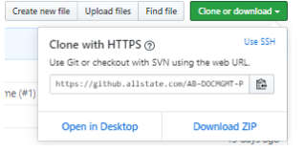
Confirmation Window will appear with a Question "Open GitHubDesktop.exe". Click the "Open GitHubDesktop.exe" Button. During this step make certain to set your destination directory to the one established for the project workspace in Step #1
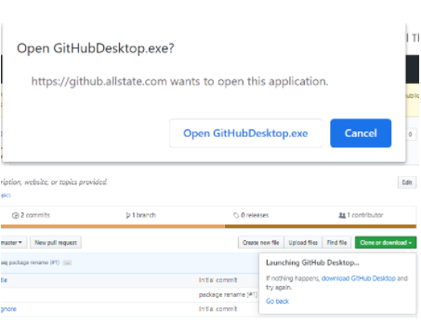

 |  | d. Redirects to the GitHub Desktop Application and Fetches repository. Allows to successfully complete.
6 | Clone any remaining Repositories to your local machine. | For our case this is repository; ab-docmgmt-proxy.  Repeat the Steps found in Step #3 (a - d)
7 | Right-Click on the Desktop Shortcut Command Prompt and "Run Elevated with DefendPoint"  ***It is a always good practice to run applications as "Run Elevated with DefendPoint" | Opens Command Prompt
8 | Navigate to the Project Workspace | C:\workspace_edmapis
9 | Validate that the Cloned Repositories are present | 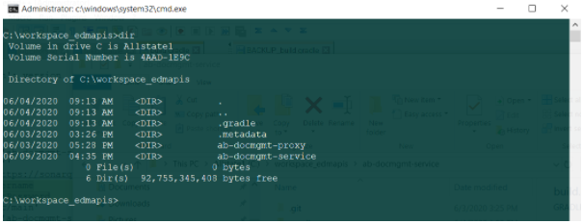
10 | Navigate to project workspace repository folder | In our case, I have chosen to navigate to the ab-docmgmt-service first. By doing so should present the following folder structure:  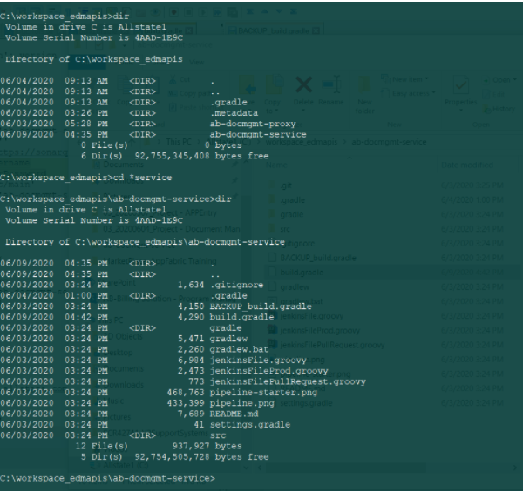
11 | Backup up the build.gradle file | Enter the following command-line statement and mash the ENTER KEY  - copy build.gradle BACKUP_build.gradle  - 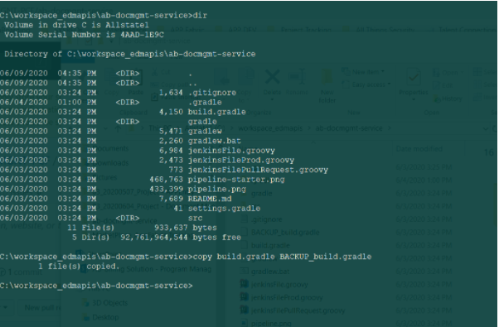
12 | Edit the build.gradle file - Save when complete | Edit the build.gradle file for the following:  a. All occurrences of System.env.SYS_USER to be replaced by System.env.LOCAL_USER  b. All occurrences of System.env.SYS_PASSWORD to be replaced by System.env.LOCAL_PASSWORD  Example of edits provided as attachment below:
13 | Build the project with "gradlew" | Notice in the previous step, that both gradle & gradlew are available. We will use the gradlew which is a wrapper for gradle in order to maintain version compatability.  NOTE: Reference the Team Confluence Page: Gradle Command Line Cheat Sheet  Proceed to type and execute the following gradlew command ( NOTE: This will compensate for logging in the event of errors )  a. gradlew -debug build > logStatements.txt 2 >> logErrors.txt file text file
14 | Repeat Steps #10 - #13 for and additional projects, like a Proxy Project for Example | file
15 | Open Eclipse LUNA IDE | Should open IDE
16 | Import an Existing Gradle Project | Navigate to the following:  File → Import  Should open a Child Window allowing the developer to select a Gradle Project
17 | Select Gradle Project to Import | Scroll Down to Gradle and Select "Existing Gradle Project".  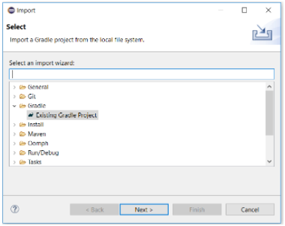
18 | Click the "Next" Button | Should open a new Child Window That Welcomes the developer to the Best Gradle Integration Experience. It is a Wizard.
19 | Click the "Next" Button | Should refresh the Child Window
20 | Select the Root Directory of the Gradle Project | For our example we have selected "C:\workspace_edmapis\ab-docmgmt-proxy"  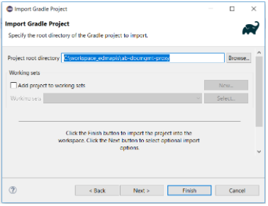
21 | Click the "Next" Button | Should refresh Child Window to the "Import Options"  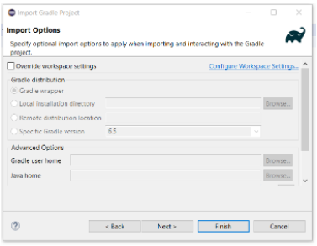
22 | Click the "Next" Button | Should automatically retrieve the "Import Options" Values. Review the values and if all looks as expected, Click the Button.
23 | Repeat Steps #16 - #22 for and additional projects, like a Proxy Project for Example
24 | Congratulations, you have successfully Imported and Built the projects within an Eclipse IDE.

